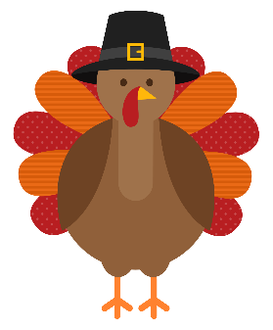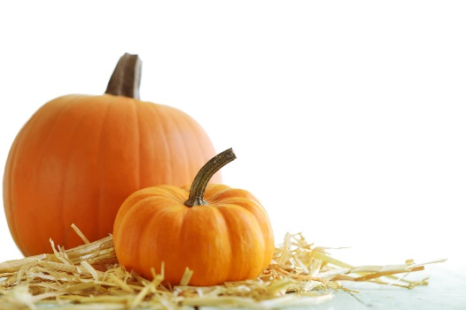**Clarkson Historical Society**

8343 West Ridge Road in Clarkson

**October/November 2024**

Clarksonhistoricalsociety.org

**Dear CHS members and friends,**

**We hope you and your family are enjoying this beautiful fall season, I was standing at the Academy office in September and happened to look out the window. The maple tree was dressed all in gold, the white church and blue sky made for a lovely picture. Perhaps this is how it looked centuries ago!**

**Our guest speaker program has been successful and as a reminder it is the first Tuesday of the month at 7pm, from April thru December. Rick Preston brought an interesting historical perspective on the Garland Cemetery on October 1. Many thanks to Rick. The next lecture will be December 3, 2024, and will be given by Sue Savard on Civil War Solder Milo Starks. Thank you to all who gave me suggestions for future speakers I am working on this and hope a list will be completed soon.**

**On October 25 the Academy was alive with two groups of Hill School groups as part of their Pioneer Day. No, they didn’t walk to school but arrived on the bus along with their teachers Mrs. Stoker and Ms. Mandel. They were greeted by our town historian Leanna Hale who took them outside to explain the Greek Revival architecture of the Academy. Then they went upstairs to our classroom where they were given brief instruction on how to write their name in cursive taught by our volunteer teachers, Carol Linenfelser and Bonnie Howlett. Then back downstairs for a history lesson by Mrs. Hale. Many thanks to our volunteers who helped make the children’s Pioneer Day at the Academy fun!**

**Our membership drive has been successful and thank you to all the members who support us. If you know someone who may be interested in becoming a member, the information can be found on our website. clarksonhistoricalsociety.org.**

**December**

3 – Membership meeting – Milo Starks, Civil War soldier

25 – Holiday Blessings to All

**January**

20 – 6 p.m. Board Meeting

2025 Cursive writing contest -

Information on CHS website

and the Westside News.

**We have been busy with making improvements on the building and hopefully by spring we will be able to use our bronze bell in the bell tower to call all to class. This has been a labor of love and hopefully completed soon.**

**Our thanks to Scott Skuza who helped put in a new thermostat and did a mini furnace check-up. Our next project will be finding contractors who are able to assist us with the roof and the entablature. We will keep you posted with updates. In addition, Ron Wiegand has been putting UV filter on the windows to protect the contents we’ve been given.**

**Leanna Hale presented at the State History Conference in Long Island in September, her topic was Bringing Back Cursive. Her PowerPoint was well accepted. The Academy, as most of you know, is active in educating our younger generation on cursive. The CHS Cursive Writing Contest will start on January 23rd the birthday of John Hancock whose signature was the most prominent on the Declaration of Independence. The contest is for students in fourth grade through high school. Contest information can be found on our website.**

**The Clarkson Historical Society has been active with the new Triangle Tract Historical Society. The society is a collaboration among four towns and two villages formed from the Triangle Tract land grant. It was formed so that the public may have information on current events in all of our small towns. Our first meeting was at the White Hall Mansion in Clarkson. Bill Andrews did an excellent job speaking on the Triangle Tract. Our local historian Leanna Hale is the current president.**

**Thank you for your support.**

**Respectfully, Anita O’Brien, President**

**October was Membership Month**

The response has been very good. Membership cards for all who have paid will be available at the December membership meeting. Instructions for finding an application are in Anita’s letter above and in the Clarkson Town Hall. They entitle the member to a 10% discount at Sara’s Garden Store. Your support is greatly appreciated.

**We’ll see you at the membership meeting December 3rd.**

Newsletter compiled by Bonnie Howlett. Information from CHS Board members.

Email to CHS: Clarksonhistorical@

gmail.com