Clarkson Historical Society**

**September 2023**

Clarksonhistoricalsociety.org

**October Membership Meeting – Tuesday, October 3rd at 7 p.m.**

Anthropologist Charles Edwards will give a presentation on the “Black Death” (Bubonic Plague) pandemic that killed between 75 and 200 million people across Europe, North Africa and the Near East in the mid 1300s. Most people today are aware of the horrors of the plague, but few are aware of how it launched a series of cultural, religious, social, political, and economic changes that ultimately made the modern world possible. He will conclude with the plague’s implications for today’s pandemics.

**October is Membership Month.**

The October CHS newsletter will be mailed to everyone. It will include the renewal application. If you do not receive this mailing, please remit your membership so that you can be put on our membership list. Information will be included in the newsletter. We appreciate your financial support.

**Summer activities of CHS:**

**Open House on August 18th**

Prior to the Good Neighbor Day celebration, the Society held an open house at the Academy for one hour between 4 and 5 p.m. Jill Akyuz gave a talk on the history of the Boss House, which is located on W. Ridge Road. This is one of the early houses in the town of Clarkson. Mr. Boss was a cabinet maker and artist. At one time one of his paintings was in the Metropolitan Museum of Art in New York City. He painted portraits of many local residents.

On the second floor, Clarkson historian Leanna Hale told about the history of the Clarkson Academy.

**The 2023 Summer School Camp**

**Calendar**

**October**

3 – 7 p.m. Charles Edwards – How the Bubonic Plague reverberates today

16 – 6 p.m. Board Meeting

**November**

7 – 7 p.m. Tom Hetherington – Reflections on return from Vietnam and return from splashdown of space capsule.

Check the Westside News and the CHS Facebook page for coming events.

This year’s camp was held from August 21-24. Again, the focus was teaching cursive writing. Ruth Rath taught along with Leslie Bull and Nancy Stone, all retired teachers from Brockport Central. It was a full morning with local history, a talk on Bees by Tadge O’Brien, making picture frames led by Karen Carges, the science of the heart led by Anita O’Brien, and Lisa Rice taught about Roman Numerals. Again, music was led by Sue Baker and Dave & Debbie Preston. Of course, there was recess and a snack.

Fifteen boys and girls participated. Gabe Tuberville, a prior winner of the cursive writing contest, attended every day and provided assistance in several areas, especially at recess. The participants left each day with smiles. We appreciate all who participated in this endeavor.

**Raise the Roof Campaign**

We know there are expenses in keeping up an old building. The people who contributed to the 2023 Raise the Roof Campaign are very much appreciated. A total of $2,625. was raised. This will be put aside to be used on repairs that have been identified. There will have to be future fundraising when the roof will need replacing.

Again, we thank all who contributed in 2023.

**We need to remember:**

**Sue Ville –** Sue, one of the organizers of the Clarkson Historical Society, passed away on June 12, 2023. She and her late husband Ike had lived in the former Houston Tavern on W. Ridge Road. Through the years, Sue has donated items from her antique business, including most of the decorated pencil boxes.

Our sympathy goes out to Barb Grady, a member of CHS, on the death of her son, **Kevin,** on September 10, 2023**.** Our condolences are sent to his whole family.

**Of interest nearby:**

Cheryl Rommes, owner of the now closed Under the Apple Tree, is reopening

this fall a special events venue called The Bushnell House. For information, email: [thebushnellhouse@gmail.com](mailto:thebushnellhouse@gmail.com) Phone: 431-6064 Events this fall:

1. October 27th & 28th – Tales and Hauntings at the Bushnell House 7-10 pm

Cost: $40.00/per person with a maximum of 10 people

To register – contact Patti Giglio at [theseoldbones.net@gmail.com](mailto:theseoldbones.net@gmail.com)

1. A group of people sitting in a room

   Description automatically generated Saturday, November 25th from 10:00 to 4:00 pm. There will be venders throughout the house. Free to all!

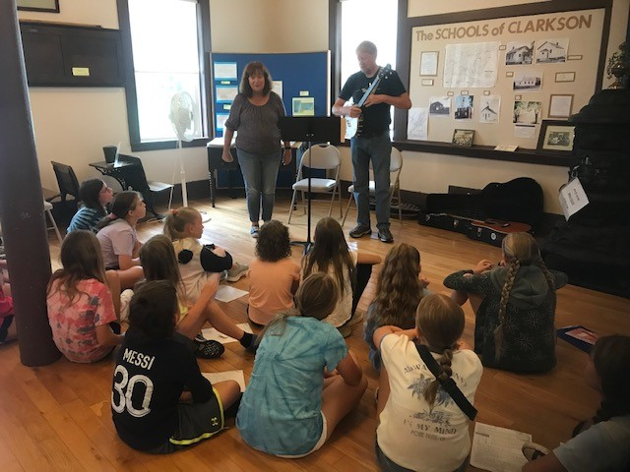

Leanna Hale, Gabe Tuberville, Leslie Bull, Pat Galinski, Anita O’Brien, Ruth Rath, Nancy Stone

Music with Sue Baker and

her sister, Ruth Rath

Music with Debbie & Dave

Preston

Newsletter compiled by Leanna Hale and Bonnie Howlett.

Email to CHS: Clarksonhistoricalsociety.com